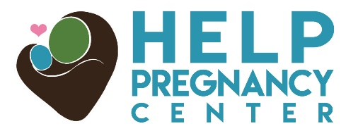
1700 Secrest Shortcut Rd. Monroe, NC 28110
www.monroehelp.com
Open: M/W 10-2, Tu/Th 10-8, and closed F/Sat/Sun
NEEDS LIST
January- Gift cards (Walmart), 20# copy paper, size 4 diapers, baby wipes, clear packing tape- 100yd. rolls, children’s 12 oz. tearless head-to-toe bath wash, socks (for 2-6 yr olds), formula(Similac), new/gently used cribs or pack-n-plays

February8oz plastic baby bottles, baby wipes, size 5 diapers, Season change; many clearance sales for children’s clothes newborn up to size 6x, any season
A good time to go through things that might be hiding and determine what to donate Teams of 4 Golf Players.

March- 13 gal. trash bags, 30 gal. trash bags, Clorox wipes, paper towels, Windex, bathroom tissue, facial tissues, postage stamps, 3”x3” post-it notes, car seats (less than 6yrs old), shoes (newborn-12.5), socks (up to age 6), PJ’s (2T-6x) Teams of 4 Golf Players.

Most Car Seats Expire After 6 Years
1700 Secrest Shortcut Rd. Monroe, NC 28110
www.monroehelp.com
Open: M/W 10-2, Tu/Th 10-8, and closed F/Sat/Sun
NEEDS LIST
April- Children’s 12oz. tearless head-to-toe body wash, 3”x3” post-it notes, size 4 diapers, baby wipes, 20# copy paper, postage stamps, newborn wash cloths & towels, breast pumps, formula (Similac), cribs or pac-n-plays
May- Maternity Clothes, postage stamps, size 5 diapers, wipes, children’s clothing sizes newborn-6x, socks (for 2-6yr olds), shoes (newborn-12.5), cribs, diaper bags, PJ’s (2T-6x), Clorox wipes, 13 gal. trash bags, paper towels, bathroom tissue, Windex

June- Gift cards (Walmart), size 4 diapers, 8oz. plastic baby bottles, baby wipes, new/gently used clothing up to size 6x, formula, car seats (less than 6yrs old), bibs, pacifiers, strollers, high chairs, bathroom tissue, 30 gal. trash bags
Most Car Seats Expire After 6 Years
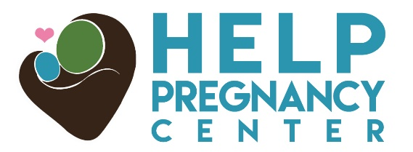
1700 Secrest Shortcut Rd. Monroe, NC 28110
www.monroehelp.com
Open: M/W 10-2, Tu/Th 10-8, and closed F/Sat/Sun
NEEDS LIST
July- Size 4 diapers, baby wipes, children’s 12 oz. tearless head-to-toe body wash, postage stamps, 3”x3” post-it notes, Clorox wipes, clear packing tape 100yd. rolls, winter baby blankets (heavy and receiving), cribs or pac-n- plays, bibs, formula (Similac)

August- Season change-many clearance sales for children’s clothes (newborn up to size 6x-any season), 13 gal. trash bags, size 5 diapers, socks (for 2-6yr olds), pacifiers, winter coats (4 to 6x), PJ’s (2T-6x), Banquet Table Hosts,

September- size 4 diapers, baby wipes, 20# copy paper, gift cards (Walmart), 8 oz. baby bottles, car seats (less than 6yrs old), 3”x3” post-it notes, bibs, pacifiers, winter coats (4-6x) , Banquet table hosts and guests
Most Car Seats Expire After 6 Years
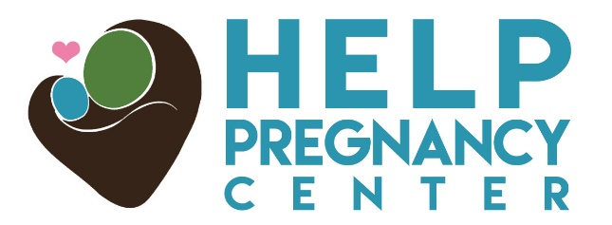
1700 Secrest Shortcut Rd. Monroe, NC 28110
www.monroehelp.com
Open: M/W 10-2, Tu/Th 10-8, closed F/Sat/Sun
NEEDS LIST
October- 12oz. tearless, head-to-toe children’s wash, size 4 diapers, wipes, postage stamps, clear packing tape 100yd. rolls, new/gently used children’s clothes up to size 6x, children’s underwear (size 2-6), high chairs, cribs or used pac-n-plays, winter coats (4 to 6x),
Adopt-A-Client sponsors-call the Center for more info-ask for Lisa

November- Winter coats (4 to 6x), size 5 diapers, socks (for 2-6 year olds), baby wipes, 8oz. baby bottles, shoes (newborn-12.5), bibs, strollers, car seats (less than 6yrs old), crib mattresses, pacifiers, formula (Similac).
Cleaning your toy box out? We need sturdy toys (gently used, with all pieces, please)
Adopt-A-Client sponsors-call the Center for more info-ask for Lisa

December-Gift cards (Walmart), size 4 diapers, baby wipes, 12oz. tearless, head-to-toe children’s wash, car seats(less than 6yrs old), strollers, socks (newborn-6x), 20 # copy paper, Clorox wipes
Baby Bottle Boomerang church participants-Sanctity of Life-> January!!
Most Car Seats Expire After 6 Years

